Narcotics Anonymous
is a fellowship of recovering addicts that
meet regularly to help each other stay clean.
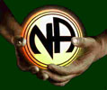

Call Narcotics Anonymous to find a meeting
or talk to another recovering addict.
NJ Statewide Helpline
800-992-0401 (NJ only) or732-933-0462
www.nanj.org

